

CSF 302
Software Engineering Department

Lab Report 2

<Submitted by> Student No:02240337

Royal University of Bhutan, College of Science and Technology

Q1: Prime Number Testing

Objective:

Test whether a number n is prime using two algorithms and compare their performance.

Algorithms:
1. Naive Method (check divisibility from 2 to n-1)
2. Optimized Method (check divisibility up to √n) 3. OPTIONAL : Find the list of primes using the sieve of Eratosthenes algorithm.

Instructions:
- Input at least 10 numbers from the user.
- For each number, determine if it is prime using both algorithms.
- Record step/frequency counts for each algorithm.
- Compare time complexities and plot a graph to identify the faster algorithm.

Output:

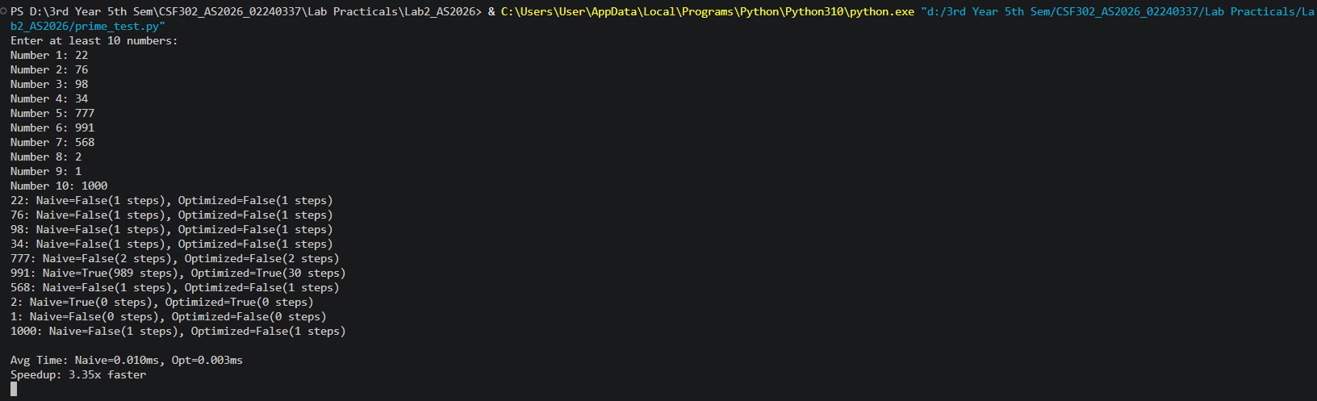

Code:

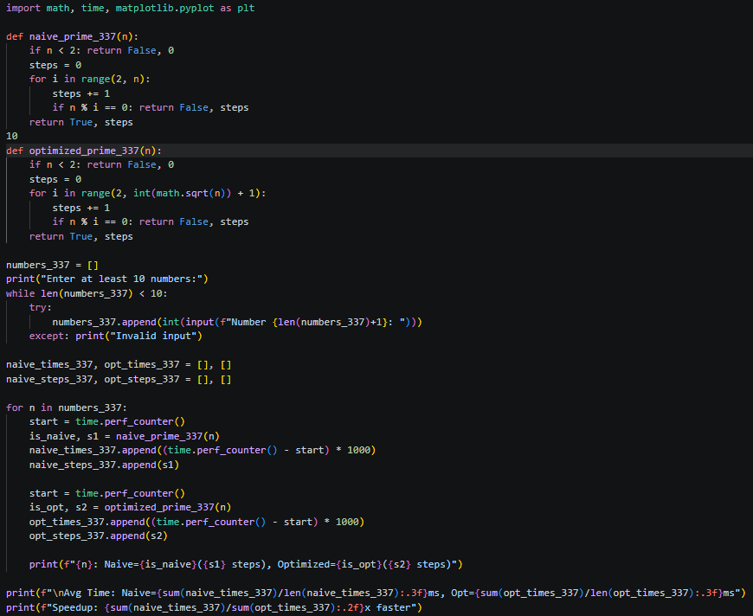

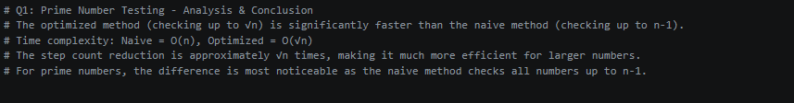

Q2: Merge Sort Analysis (Menu-Driven Program)

Objective:
Write a menu driven program to Sort an array of n integers in ascending order using Merge Sort and analyze step/frequency counts for different input types.

Menu:
1. Generate n random numbers → Array
2. Display Array
3. Sort in Ascending Order using Merge Sort
4. Sort in Descending Order using any sorting algorithm
5. Time Complexity for ascending random data
6. Time Complexity for ascending already sorted data
7. Time Complexity for ascending descending-sorted data

Instructions:
- Record step/frequency counts.

Output:

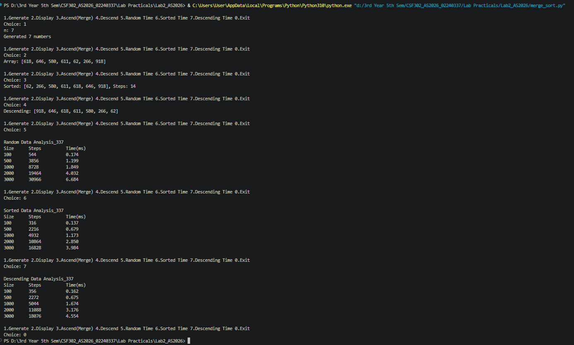

Code:

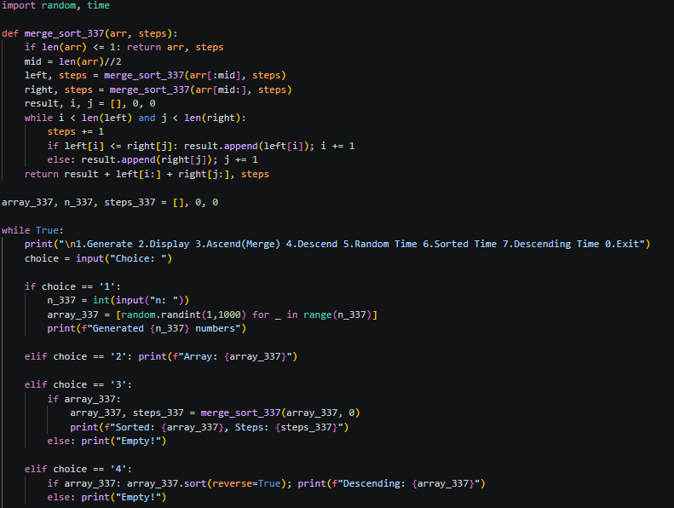

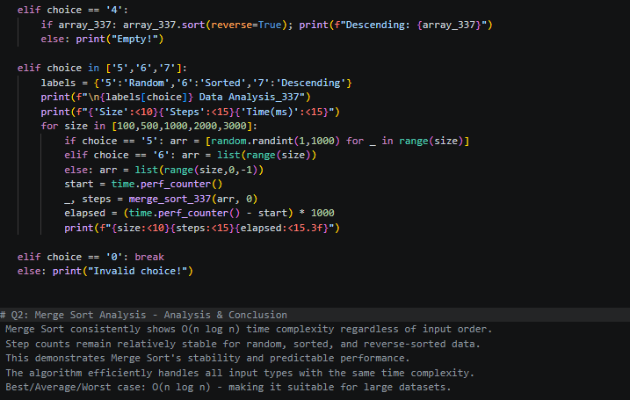

Q3: Square Matrix Multiplication

Objective:
Multiply two square matrices (n × n), Note: make the matrix as a power of 2, eg, 2x2, 4x4, 8x8...etc.

Instructions:
- Input matrices manually or generate randomly.
- Display the resultant matrix.
- Count the number of basic operations (step/frequency count).

Output:

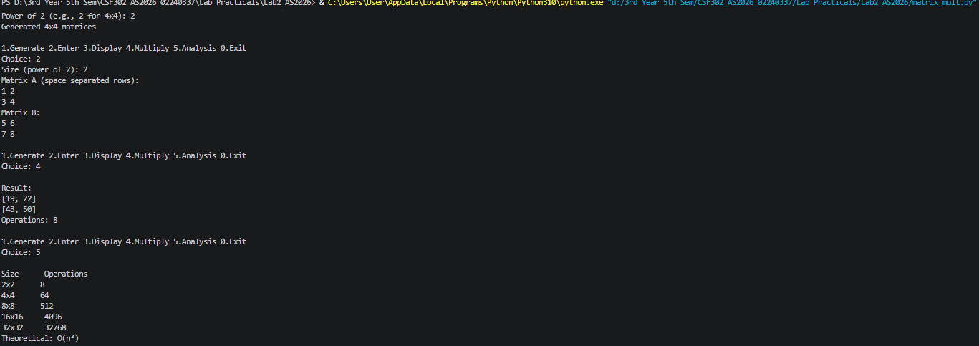

Code:

